**Saidan Shafi**

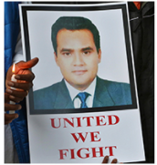

**About :** Shafi a reporter for Doordarshan TV, the official Indian television network, for “Kashmir File,” a weekly news program. Shafi ran a program that was critical of the Kashmiri separatists. Following his report, Shafi reportedly received death threats from separatists for his ‘biased’ reportage.

**Murdered on :** March 16, 1997

**Attack details :** He was shot in an ambush by two gunmen in Srinagar, Kashmir. His personal security guard also was killed in the attack.

**Reason to him target :**  Shafi reportedly received death threats from separatists for his biased reportage.

**Occupation :**  Reporter for Doordarshan TV, the official Indian television network.

**Belief** **:** The language a reporter writes in and, most importantly, what they are writing about—especially if it challenges the powerful increase the vulnerability.

**URL:** <http://www.jammu-kashmir.com/archives/archives1997/97march16.html>